

ITA0330-Mobile Computing

Name: T. Dharani Devi Reg no:192425036

Slot: D Course Name: Mobile Computing

Experiment 4: Mobile Network Protocol Stack
Aim: To create a visual representation highlighting the key elements of mobile network protocol stacks.
Procedure:
- Open Figma and create a new design file.
- Create a frame for the protocol stack diagram.
- Draw separate boxes for the Physical and Data Link layers.
- Add Network, Transport, and Application layers.
- Write the main function of each layer inside its box.
- Arrange the layers vertically and connect them using arrows.
- Apply different colors and labels to make the diagram easy to understand.

Output:

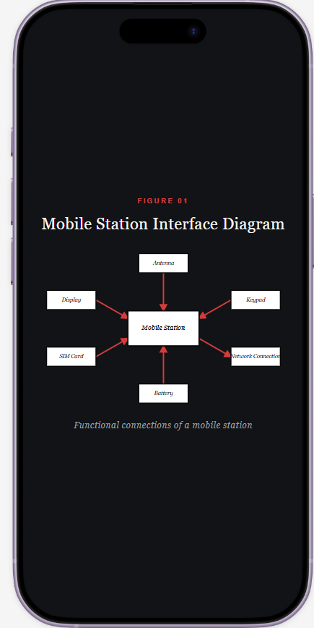

https://www.figma.com/make/j0Wi8J8KvrU0sbkUbOx2PM/EXPERIMENT-4?p=f&t=rYs7ltx27JTLoS86-0
Result: Thus, a visual representation of the mobile network protocol stack was created successfully.

